| Course name | Numerical Modelling & Simulation in Scilab Xcos |
| --- | --- |
| **Lesson name** | **Electric Vehicle Powertrain Modelling Level 3 project** |
| **Lesson objective** | **Model a two speed transmission** |
| Created by | THATHIREDDY HEMANTH |

**Problem statement:** Model the two-speed transmission and optimize the gear ratios as best as possible for the drive cycle.

**Drive Cycle Graph:**

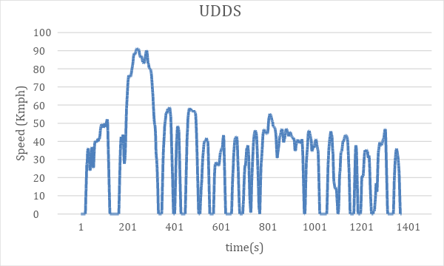

**Procedure taken For Optimization:**

Tried using the trail and error method

1. Fixed the G1 value and varied the G2 value in order find the point at which we cam get max efficiency.
2. Fixed the G1 value and varied the G2 value in order find the point at which we cam get max efficiency.
3. Identified the values at which I can get max efficiency among the above two steps.
4. Performed the simulation by using taking the higher efficiency values form the step 1 and step 2 in order to get higher efficiency of the motor.

**Step 1: G1 is fixed**

| **G1** | **G2** | **Efficiency** |
| --- | --- | --- |
| 11.09 | 7.96 | 89.77% |
|  | 6.96 | 90.38% |
|  | 5.96 | 90.92% |
|  | **5.38** | **91.21%** |

**Step 2: G2 is fixed**

| **G2** | **G1** | **Efficiency** |
| --- | --- | --- |
| 7.96 | 11.09 | 89.77132% |
|  | 10.09 | 89.7746% |
|  | 1. 10.14 | 89.774714% |
|  | 1. 10.15 | 89.774715% |
|  | 1. **10.16** | **89.774715%** |
|  | 1. 10.17 | 89.774715% |
|  | 1. 10.18 | 89.774714% |
|  | 9.80 | 89.7742% |
|  | 9.09 | 89.76% |

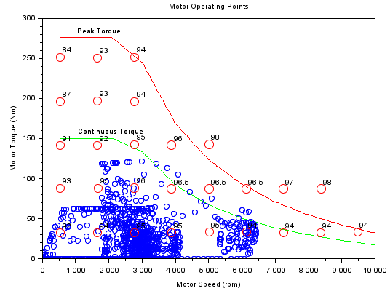

**Efficiency after optimization at G1(11.09),G2(7.96) = 89.77132%**

**Efficiency after optimization at G1(10.16),G2(5.38) = 91.2228%**

**Model Inputs:**

| **Sl No** | **Parameter** | **Value** | **Units** |
| --- | --- | --- | --- |
|  | Chassis |  |  |
|  | **Torque** |  |  |
|  | * **Force** |  |  |
|  | 1. **Rolling Resistance Force** |  |  |
|  | 1. Coefficient of rolling resistance | 0.015 |  |
|  | 1. Mass of Vehicle | 1710.665 | kg |
|  | 1. Mass of Driver |  |  |
|  | 1. Gravity constant | 9.81 | m/s |
|  | 1. **Gradient Force** |  |  |
|  | 1. Mass of Vehicle | 1710.665 | kg |
|  | 1. Mass of Driver |  |  |
|  | 1. Grade Angle | 25 | Degrees |
|  | 1. Degrees to radians conversion factor | Pi/180 | Rad/s |
|  | 1. **Aerodynamic Force** |  |  |
|  | 1. Velocity | 100 | Km/h |
|  | 1. Kmph to mps conversion factor | 27.774 | m/s |
|  | 1. Constant | 0.5 |  |
|  | 1. Area | 3.8056 | m^2 |
|  | 1. Air Density | 1.225 | Kg/m^3 |
|  | 1. Drag Coefficient | 0.28 |  |
|  | 1. **Acceleration Force** |  |  |
|  | 1. Mass of vehicle | 1710.665 | kg |
|  | 1. Mass of Driver |  |  |
|  | 1. Kmph to mps conversion factor | 27.774 | m/s |
|  | 1. **Wheel Speed** |  |  |
|  | Radius of wheel | 0.2032 |  |
|  | 1. **Motor** |  |  |
|  | Rpm to rad/s | 1088.03825445 | Rad/s |
|  | Motor Efficiency | 91.2228 | % |

**Program:**

| 1. **To Import Data:** | 1. **To define all input parameters:** |
| --- | --- |
| *//Importing Drive CYcle Data*  data = csvRead("UDDS.csv")  UDDS.time = data(4:1372,1)  UDDS.values = data(4:1372,2)  *//impoting motor efficiency Data*  ME = csvRead("M E.csv")  *//motor speed*  s = ME(2:16,1)  t = ME(2:16,17)  e = ME(2:16,2:16)  subplot(221)  surf(s,t,e)  xlabel("Motor Speed(rpm)")  ylabel("Motor Torque(Nm)")  zlabel("Motor Efficiency (%)")  title("Motor Efficiency Plot")  *//Importing Regenerayive motor Data*  MRE = csvRead("M Re.csv")  *//motor speed*  sr = MRE(2:16,1)  tr = MRE(2:16,17)  er = MRE(2:16,2:16)  subplot(223)  surf(sr,tr,er)  xlabel("Motor Speed(rpm)")  ylabel("Motor Regenerayive Torque(Nm)")  zlabel("Motor Regenerayive Efficiency (%)")  title("Motor Regenerayive Efficiency Plot")  MRE = csvRead("M Re.csv") | //Vehicle Dynamics  //Radius of the wheel  Rw = 0.2032 //m  //Coefficient of rolling resistance  Crf=0.015  //Gross Vehicle Mass  GVM=1710.665 //Kg  //Gross vehicle Weight  GVW=GVM*9.81 //N  //Area  A = 3.8056  //Coefficient of Drag  Cd = 0.28  //Transmission  //Transmission Efficiency  Neff = 0.89 |

**Results:**

| **Rolling Force** | **Gradient Force** |
| --- | --- |
|  |  |
| **Aerodynamic Force** | **Acceleration Force** |
|  |  |
| **Wheel Speed:** | **Wheel Torque:** |
|  |  |
| **Motor Speed:** | **Motor Torque:** |
|  |  |
| **Motor Power:** |  |
|  |  |

**Conclusion:**

| **SL No** | **Parameters** | **Value** | **Units** |
| --- | --- | --- | --- |
|  | **Chassis** |  |  |
|  | Rolling Force | 251.7 | N |
|  | Gradient Force | 0 | N |
|  | **Motor** |  |  |
|  | Peak Torque | 121.63696 | Nm |
|  | Peak Power | 46722.335 | W |